- Project title
Student Grade Management System

- Group member names
Xiaoyun Hou
Rakshya KC
LittleDragon
Long Toni

- GitHub repository link
https://github.com/houxiaoyun0-eng/student-grade-management-system-Group1
- Explanation of the program logic
This program is a menu-driven student grade management system that allows users to manage student data efficiently. This project has three main parts, one is the main method which shows this project the main structure .And then use menu to display the functions of this projects, the third part is used for allocating each method. This program use a while loops to keep displaying the menu until user chooses one.

- Explanation of major functions/methods used
- Paralled arrays- one array for student names ,one array for student grades ,use add Students method to show a student’s name and corresponded grade.
- Showmenu() can displays all menu options at same time to the user.
- displayStudents()- user can see all the students names and their corresponding scores.
- Highest/lowest()-Find and displays the highest and lowest grades.
- Count- work with several methods like add students names, caculate average scores, highest and lowest scores.

- Screenshots of sample runs

Sample1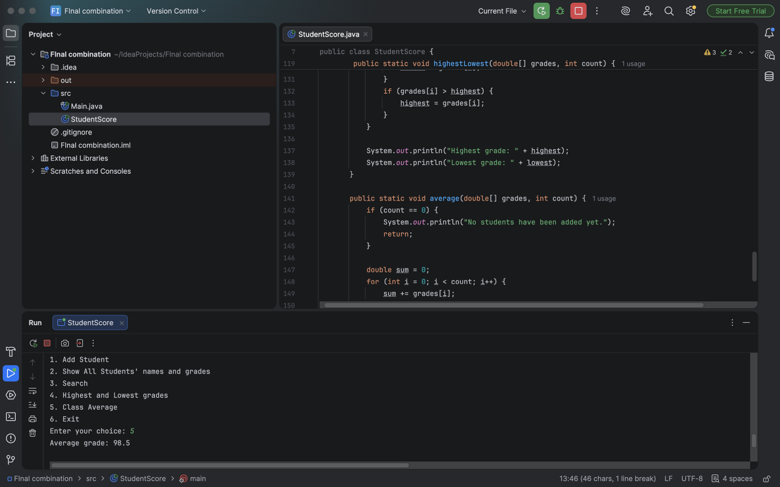
Sample-2

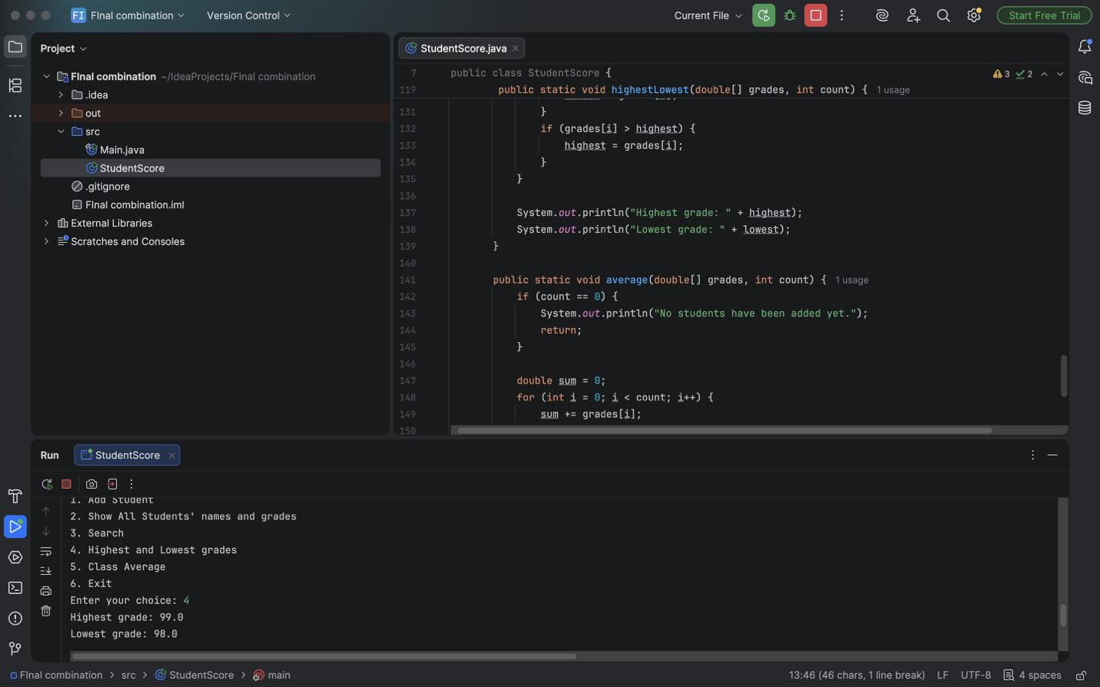
Sample-3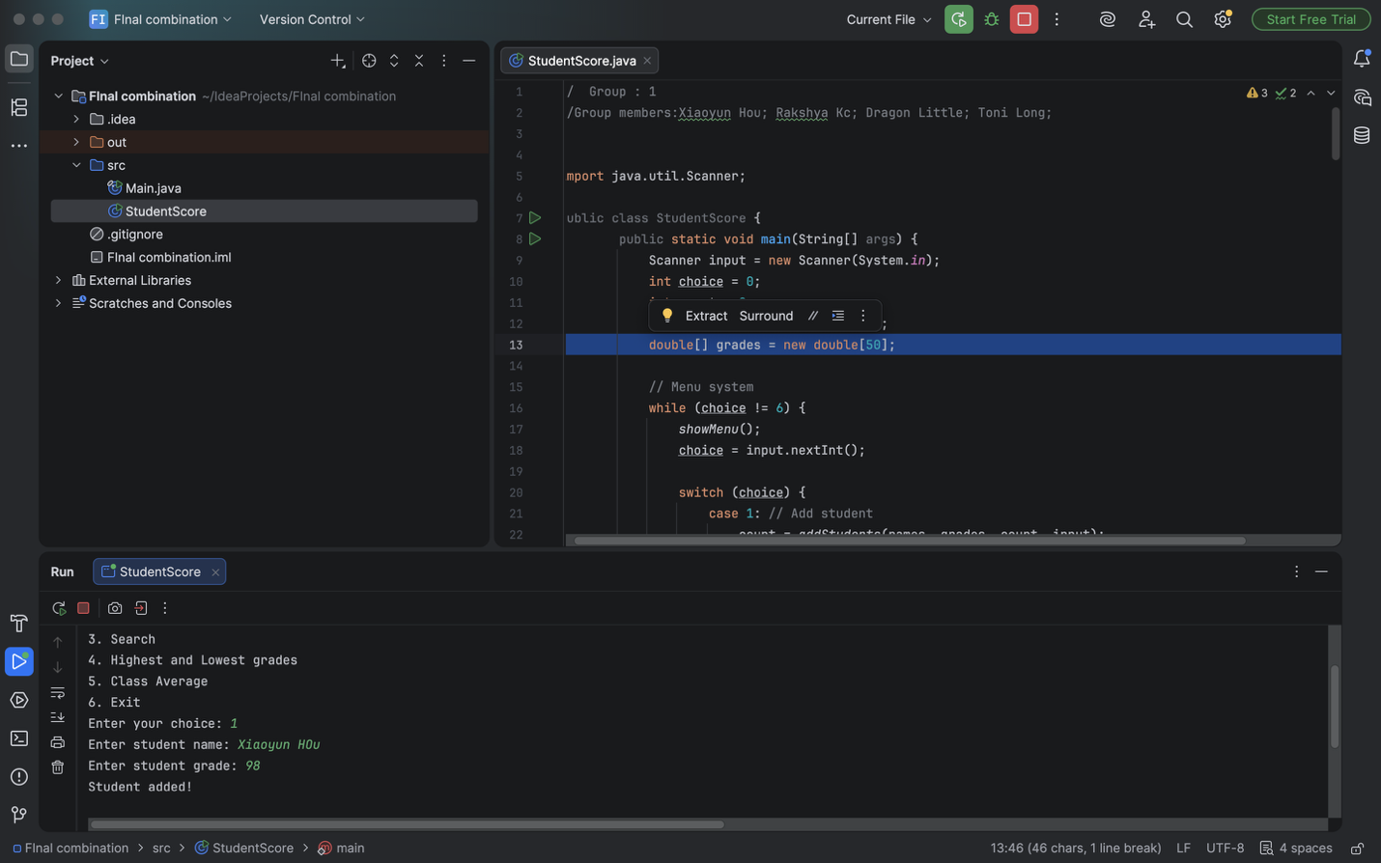

- Individual contributions of each group member
Xiaoyun Hou
• Completing the menu system
• Implementing addStudents, displayStudents, average, and exit functions
• Fixing errors and integrating the entire program
Rakshya KC
- Contributed to research and testing parts of the program.
Littledragon
- Worked on part of the menu structure and implemented the highest and lowest functions.
Long Toni
- Assisted with GitHub repository setup and report organization.

